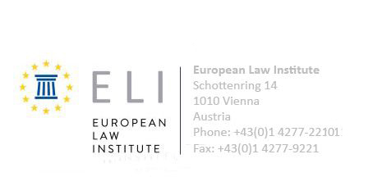

Certification of Attendance

This certificate is a confirmation that Mrs. Irina Getman-Pavlova attended the Conference organized by the European Law Institute, held in Brussels on 28 – 29 th of September 2012.

29 September 2012

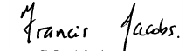
Sir Francis Jacobs
President, European Law Institute

